**GOVERNMENT COLLEGE OF ENGINEERING ERODE**



B.E Electronics and Communication Engineering

**MEASURE ENERGY CONSUMPTION**

**Name of the Students: University Register no:**

**S.ANBURAJ au731121106303**

**S.THANUSH VISHAL au731121106051**

**V.BOOPATHI RAJ au731121106003**

**K.DHARANEESWARAN au731121106008**

**S.PRABHAKARAN au731121106035**

Under the mentor of

**Dr. M. Poongothai**

**Assistant professor, Dept. of IT Department of Information Technology (IT)**

**Department of Electronics and Communication Engineering**

Government College of Engineering

Erode, PO, near Vasavi College, TamilNadu-638316,

Affiliated to Anna University, Chennai

Measure Energy Consumption

Measuring energy consumption in AI is an important step towards making AI systems more sustainable and environmentally friendly. Here are the project steps to measure energy consumption in AI:

**Define the Scope** and **Objectives:**

Clearly define the scope of your project. Determine what aspects of AI you want to measure energy consumption for and establish your project's objectives. Are you focusing on a specific AI model, hardware, or a broader AI ecosystem?

Gather Necessary Resources:

Collect the required resources, including hardware, software tools, and datasets. You may need specialized energy measurement equipment, AI models, and relevant software libraries.

Select Metrics:

Choose the energy consumption metrics you want to measure. Common metrics include power consumption (Watts), energy usage (Joules), and carbon footprint (CO2 emissions). Make sure to align this metrics with this project's goals.

Set Up Energy Measurement Tools:

Set up the necessary hardware and software tools to measure energy consumption accurately. This may involve using power meters, energy measurement software, and data collection systems.

Instrument AI Systems:

Integrate energy measurement instruments with the AI systems to analyze. This might involve installing power measurement devices, configuring sensors, or using software-based energy profiling tools.

Block Diagram:

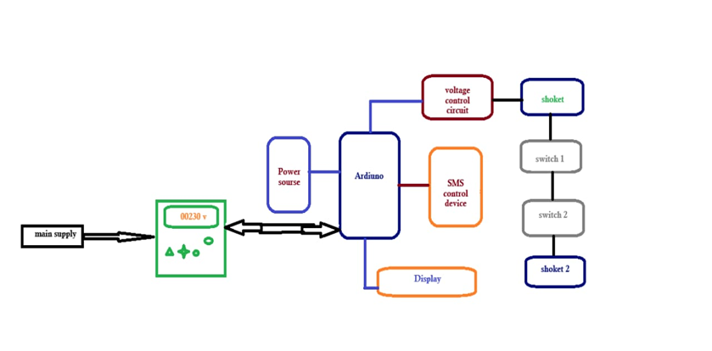

Collect Data:

Run AI workloads or models while continuously collecting energy consumption data. Ensure that you collect data under different conditions to analyze variations in energy usage.

Analyze Energy Consumption:

Use statistical and analytical techniques to analyze the energy consumption data. Look for trends, patterns, and variations in energy usage.

Report Findings:

Prepare a comprehensive report detailing your findings and insights regarding AI energy consumption. Include graphs, tables, and visualizations to make the information more accessible.

Dissemination:

Share your findings with the AI community, industry, and relevant stakeholders through publications, conferences, or online platforms. This will help raise awareness and promote sustainable AI practices.

Continual Monitoring:

Establish a system for continual monitoring of AI energy consumption to track improvements and assess the impact of any implemented changes. Measuring and reducing energy consumption in AI is crucial for the sustainability of AI technologies. By following these steps, you can contribute to more eco-friendly AI practices and help mitigate the environmental impact of artificial intelligence.

Conclusion:

In this project, we embarked on a crucial mission to measure and understand the energy consumption of AI systems. Our primary objective is to shed light on the environmental impact of AI technologies and provide insights into optimizing energy usage in this domain. Through a systematic approach, we collected data, analyzed results, and offered recommendations for a more sustainable AI ecosystem.